[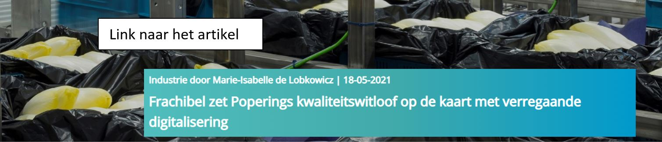](https://magazine.siemens.be/frachibel-poperings-kwaliteitswitloof-met-digitalisering/?profileid=1250303&profilesource=Eloqua&elqTrackId=57b1feaa3d5f4b3993def96c33205dac&elq=b6f91587fc75424e8e5744fee82ef003&elqaid=40238&elqat=1&elqCampaignId=20290&elqcst=272&elqcsid=18305)